**MOBILE COMPUTING AND WIRELESS NETWORKS**

**Chapter One Overview-**Transmission Fundamentals-Signals for Conveying Information, Channel Capacity, Transmission Media, and Multiplexing

**1.1 Wireless Transmission**

While transmission over different wires typically does not cause interference this is an important topic in wireless transmission. The frequencies used for transmission are all regulated. The first section gives a general overview of these frequencies. Transmission requires signals antennas, and signal propagation The varying propagation characteristics create particular complications for radio transmission, frequently causing transmission errors. Multiplexing is critical in this field because the medium is always shared. Multiplexing schemes have to ensure low interference between different senders. Lastly modulation is needed to transmit digital data via certain frequencies.

**1.2 Frequency Spread Spectrum**

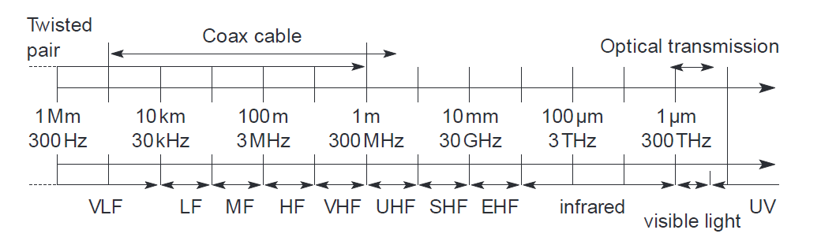

**Figure 1 Frequency Spectrum**

**Frequencies for radio transmission**

Radio transmission can take place using many different frequency bands. Each frequency band exhibits certain advantages and disadvantages. Figure 1. gives a rough overview of the frequency spectrum that can be used for data transmission. The figure shows frequencies starting at 300 Hz and going up to over 300 THz Directly coupled to the frequency is the wavelength λ via the equation:

λ = c/f,

where c ≅ 3·108 m/s (the speed of light in vacuum) and f the frequency. For traditional wired networks, frequencies of up to several hundred kHz are used for distances up to some km with twisted pair copper wires, while frequencies of several hundred MHz are used with coaxial cable. Fiber optics are used for frequency ranges of several hundred THz, but here one typically refers to the wavelength which is, e.g.,1500 nm, 1350 nm etc. (infrared).

Radio transmission starts at several kHz, the very low frequency (VLF) range. These are very long waves. Waves in the low frequency (LF) range are used by submarines, because they can penetrate water and can follow the earth’s surface. Some radio stations still use these frequencies, e.g. between 148.5 kHz and 283.5 kHz in Germany.

The medium frequency (MF) and high frequency (HF) ranges are typical for transmission of hundreds of radio stations either as amplitude modulation (AM) between 520 kHz and 1605.5 kHz, as short wave (SW) between 5.9 MHz an d 26.1 MHz, or as frequency modulation (FM) between 87.5 MHz and 108 MHz. The frequencies limiting these ranges are typically fixed by national regulation and, vary from country to country. Short waves are typically used for (amateur) radio transmission around the world, enabled by reflection at the ionosphere. Transmit power is up to 500 kW which is quite high compared to the 1 W of a mobile phone.

As we move to higher frequencies, the TV stations follow. Conventional analog TV is transmitted in ranges of 174–230 MHz and 470–790 MHz using the very high frequency (VHF) and ultra-high frequency (UHF) bands. In this range, digital audio broadcasting (DAB) takes place as well (223–230 MHz and 1452–1472 MHz) and digital TV (470–862 MHz). While, the old frequencies for analog TV are been reused. UHF is also used for mobile phones with analog technology (450–465 MHz), the digital GSM (890–960 MHz, 1710–1880 MHz), digital cordless telephones following the DECT standard (1880–1900 MHz), 3G cellular systems following the UMTS standard (1900–1980 MHz, 2020–2025 MHz, 2110–2190 MHz) and many more. VHF and especially UHF allow for small antennas and relatively reliable connections for mobile telephony.

Super high frequencies (SHF) are typically used for directed microwave links (approx. 2–40 GHz) and fixed satellite services in the C-band (4 and 6 GHz), Ku-band (11 and 14 GHz), or Ka-band (19 and 29 GHz). Some systems are planned in the extremely high frequency (EHF) range which comes close to infrared. All radio frequencies are regulated to avoid interference. The next step into higher frequencies involves optical transmission, which is not only used for fiber optical links but also for wireless communications. Infrared (IR) transmission is used for directed links, e.g., to connect different buildings via laser links. The most widespread IR technology, infrared data association (IrDA), uses wavelengths of approximately 850–900 nm to connect laptops, PDAs etc. Finally, visible light has been used for wireless transmission for thousands of years. While light is not very reliable due to interference, but it is nevertheless useful due to built-in human receivers.

**1.3 Signals**

Signals are the physical representation of data. Users of a communication system can only exchange data through the transmission of signals. Layer 1 of the ISO/OSI basic reference model is responsible for the conversion of data, i.e., bits, into signals and vice versa.

Therefore, a signal is essentially a time-varying quantity. It can be an electrical voltage, or could be some other quantity, which can be changed or modulated easily, such as radio-frequency power or optical (light) power. It is used to carry information from one end of a communications channel (the sender or transmitter) to the receiving end. For example, modulating a voice signal so that it may be transmitted through free space or encoding data bits on a wire all entail some sort of processing of the signal

A voltage that changes in some known fashion over time is termed a waveform, and that waveform carries information as a function of time.

Signals are functions of time and location. Signal parameters represent the data values. The most interesting types of signals for radio transmission are periodic signals, especially sine waves as carriers. The general function of a sine wave is

g(t) = At sin (2πft t + φt)

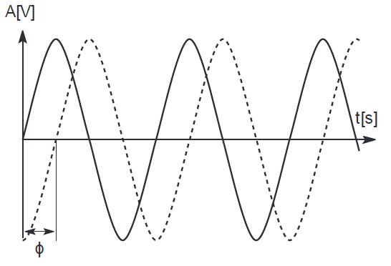

Figure 2 Time domain representation of a signal

Signal parameters are the amplitude A, the frequency f, and the phase shift φ. The amplitude as a factor of the function g may also change over time (At). The frequency f expresses the periodicity of the signal with the period T = 1/f. (In equations, ω is frequently used instead of 2πf.) The frequency f (ft). Finally, the phase shift determines the shift of the signal relative to the same signal without a shift. An example for shifting a function is shown in Figure 2. This shows a sine function without a phase shift and the same function, i.e., same amplitude and frequency, with a phase shift φ.

With Sine waves we can construct every periodic signal g by using only sine and cosine functions according to fundamentals of Fourier equation. We can transmit signals as composed of one or many sine functions. The example is of one sine function, i.e. the case of a single frequency. A typical way to represent signals is in the time domain (see Figure 3.). Here the amplitude A of a signal is shown versus time (time is mostly measured in seconds s, amplitudes can be measured in, e.g., volt V or current I). This is also the typical representation known from an oscilloscope. A phase shift can also be shown in this representation.

Representations in the time domain are problematic if a signal consists of many different frequencies (as the Fourier equation indicates). In this case, a better representation of a signal is the frequency domain (see Figure 4). Here the amplitude of a certain frequency part of the signal is shown versus the frequency. Figure 4 only shows one peak and the signal consists only of a single frequency part (i.e., it is a single sine function). Arbitrary periodic functions would have many peaks, known as the frequency spectrum of a signal. A tool to display frequencies is a spectrum analyzer. Fourier transformations are a mathematical tool for translating from the time domain into the frequency domain and vice versa (using the inverse Fourier transformation).

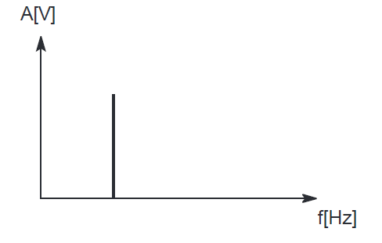

Figure 4. Frequency domain representation of a signal

A third way to represent signals is the phase domain shown in Figure 5. This representation, also called phase state or signal constellation diagram, shows the amplitude M of a signal and its phase φ in polar coordinates. (The length of the vector represents the amplitude, the angle the phase shift.) The x-axis represents a phase of 0 and is also called In -Phase (I). A phase shift of 90° or π/2 would be a point on the y-axis, called Quadrature (Q).

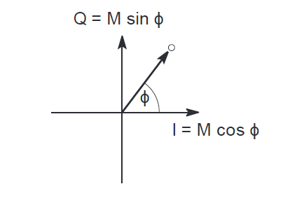

Figure 5. Q = M sin ϕ Phase domain representation of a signal

In many communication systems, it is necessary to delay a signal by a certain amount. If this delay is relative to the frequency of the signal, it is a constant proportion of the total cycle time of the signal. In that case, it is convenient to write the delay not as time, but as a phase angle relative to 360∘ or 2π rad (radians). As with delay, it is useful to be able to advance a signal, so that it occurs earlier with respect to a reference waveform. This may run a little counter to intuition, since after all, it is not possible to know the value of a signal at some point in the future. However, considering that a signal is repetitive (or at least, for as long as we wish to observe it), then an advance of say one-quarter of a cycle or 900 is equivalent to a delay of 90 − 360 = −2700

**1.4 Mobile Radio Channel**

For wireless communications, the transmission medium is the radio channel between transmitter Tx and receiver Rx. The signal can get from the Tx to the Rx via a number of different propagation paths. In some cases, a Line-Of-Sight (LOS) connection might exist between Tx and Rx. In a typical mobile environment LOS is absent and the signal can get from the Tx to the Rx by means of being reflected at or diffracted by different objects in the environment: houses, mountains (in some hilly areas), windows, walls and so on. The number of these possible propagation paths is normally very large. Each of the paths has a distinct amplitude, delay (runtime of the signal), direction of departure from the Tx and direction of arrival; most importantly, the components have different phase shifts with respect to each other.

The envelope of the received signal is composed by many signal replicas arriving via different paths with different amplitudes and phases, respectively. When the phase shift between each pair of signal components is equal to 180∘, these components tend to cancel each other out producing a case of destructive interference, and vice versa, when signal replicas arrive in-phase they tend to add up to each other; that is, a case of constructive interference. Due to the random nature of amplitude and phase of the multipath component, the subsequent composition produces random variations in a received signal envelope. These variations are called ‘fading’.

An ideal transmission channel would be the one in which the received signal is equal to the transmitted one. Nevertheless, it is known that real channels introduce an attenuation and a phase shift to signals. When the attenuation is constant over the signal's frequency components (i.e., over the entire signal's bandwidth), it is said that the channel does not introduce amplitude distortion to signals. Similarly, when the phase shift is linear over the signal's frequency component, it is said that the channel does not introduce phase distortion to signals.

**1.5 Transmission Media**

A transmission medium is the physical path between the transmitter and receiver in a communication system. The characteristics and quality of transmission depend on the nature of the signal and the nature of the medium.

Two general ranges of frequencies are of interest. Microwave frequencies cover a range of about 2 to 40 GHz. At these frequencies, highly directional beams are possible. Microwave is quite suitable for point-to-point transmission. Signals in the frequency range 30 MHz to 1 GHz are referred to as radio waves. Omnidirectional transmission is used and signals at these frequencies are often employed for broadcast applications.

The following are the commonly used transmission mediums used in wired and wireless communications:

* Twisted pair
* Coaxial cable
* Fiber optics
* Terrestrial microwave
* Radio
* Satellite

A *twisted pair* contains two insulated copper wires arranged in a regular spiral pattern. A wire pair acts as a single communication link. Typically, a number of these pairs are bundled together into a cable by wrapping them in a tough protective sheath. Over longer distances, cables may contain hundreds of pairs. The twisting of the individual pairs minimizes electromagnetic interference between the pairs. The wires in a pair have a thickness of 0.016 to 0.036 in. The twisted pair is by far the most common medium for both analog and digital data transmission. It is the backbone of the telephone system as well as the workhorse for intra-building

communications.

A *coaxial cable* is simply a transmission line consisting of a pair made up of an inner conductor surrounded by a grounded outer conductor, which is held in a concentric configuration by a dielectric. Systems have been designed to use coaxial cable as a transmission medium with a capability of transmitting an FDM configuration from 120 to 10,800 voice channels. Community antenna television (CATV) systems use single cable for transmitting a bandwidth of the order of 300 MHz.

One of the advantages of coaxial cable systems is reduced noise accumulation when compared to radio links. A coaxial cable system is attractive for television transmission or other video applications.

*Fiber optics* as a transmission medium has a comparatively unlimited bandwidth. It has excellent attenuation properties — as low as 0.25 dB/km. A major advantage of fiber optics compared to coaxial cable is that no equalization is needed. Also repeaters separation of the order of 10 to 1000 times that of coaxial cable for equal transmission bandwidths can be used. Other advantages of fiber optics are:

* Electromagnetic immunity
* Ground loop elimination
* Security
* Small size and light weight
* Expansion capabilities require change out of electronics only, in most cases.

Fiber optics uses three wavelength bands: around 800, 1300, and 1600 nm or near-visible infrared. Fiber optics has analog transmission applications, particularly for video/TV.

The primary use of *terrestrial microwaves* is in long-haul telecommunications service as an alternative to coaxial cable for transmitting television and voice. Microwaves can support high data rates over long distances. The microwave requires far fewer amplifiers or repeaters than coaxial cable for the same distance, but requires line-of-sight transmission. One of the potential uses for terrestrial microwaves is to provide digital data transmission in small regions (radius of 10 km). Another common use of microwaves is for short point-to-point links between buildings. It can also be used as a data link between local area networks.

The principal difference between *radio* and microwaves is that radio is omnidirectional and microwaves are focused. Radio does not require dish-shaped antennas, and the antennas need not be rigidly mounted to precise alignment. Radio covers VHF and some UHF bands: 30 MHz to 1 GHz. A primary source of impairment for radio waves is multipath interference. Reflection from land, water, and natural or human-made objects can create multiple paths between antennas. This effect is frequently evident when TV reception displays multiple images as a plane passes by.

*Satellite* communication is nothing more than a radio link communication using one or two RF repeaters located at great distances from terminal earth stations. If the range from an earth antenna to a satellite is the same as the satellite altitude, the round-trip delay is around 500 ms, which is more than that encountered in conventional terrestrial systems. Thus, one major problem is propagation time and the resulting echo on telephone circuits. To reply for packet transmission systems affects the delay and requires careful selection of telephone signaling systems, otherwise the call setup time may become excessive.

The equatorial orbit is filling with geostationary satellites and RF interference from one satellite system to another is increasing. The most desirable frequency bands for commercial satellite communication are in the spectrum 1000–10,000 MHz.

**1.6 Multiplexing**

Multiplexing refers to a variety of techniques that are used to make an efficient use of transmission facility. In many cases, the capacity of transmission facility exceeds the requirements for the transfer of data between two devices. That capacity can be shared among multiple transmitters by multiplexing a number of signals onto the same medium. In this case, the actual transmission path is called a circuit or link, and the portion of capacity devoted to each pair of transmitter/receivers is called a channel.

There are three types of multiplexing techniques: frequency-division multiplexing (FDM), synchronous time-division multiplexing (TDM), and improved synchronous TDM. FDM is the most widespread. TDM is commonly used for multiplexing digitized voice streams. The third type improves the efficiency of synchronous TDM. It is known by various names:

* Statistical TDM
* Asynchronous TDM
* Intelligent TDM

Figure 6 shows the concept of multiplexing. We have m inputs to a multiplexer. The multiplexer is connected by a single data link to a demultiplexer.

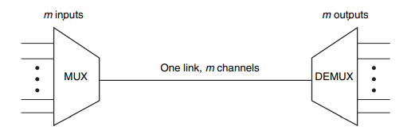

**Figure 6. Concept of Multiplexing**

The link carries m separate channels of data. The multiplexer combines data from m input lines and transmits over a higher-capacity data link. The demultiplexer accepts the combined data stream, separates the data according to channel, and delivers them to the appropriate output lines.